**Java String**

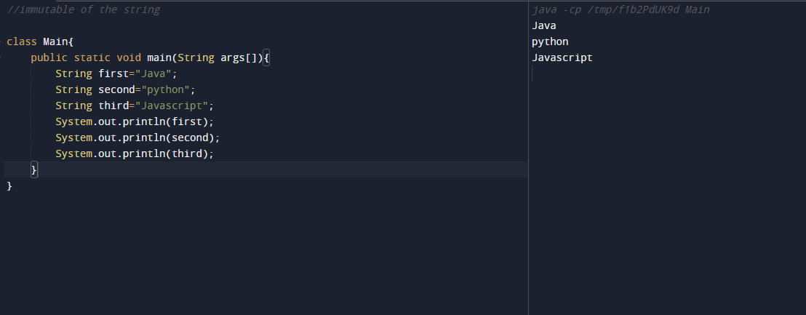

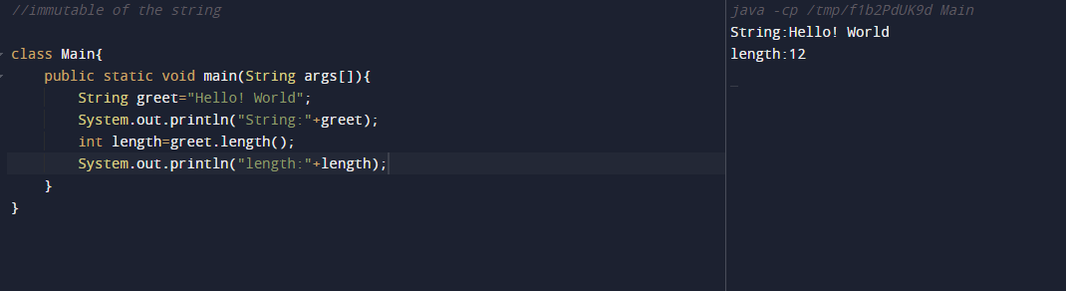

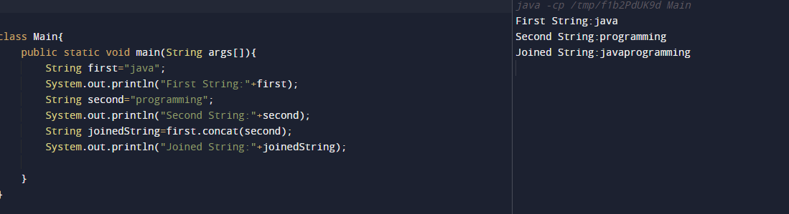

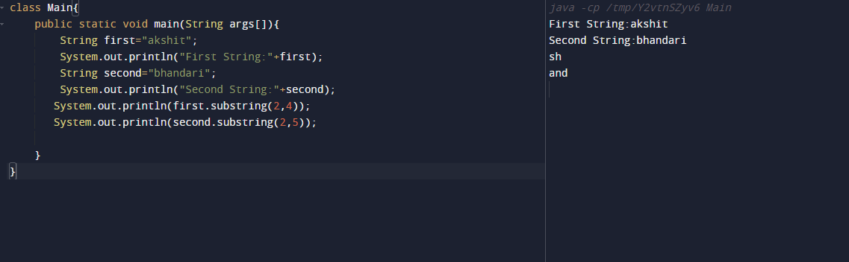

**import java.util.Scanner;**

**public class Main{**

**public static void main(String args[]){**

**Scanner sc=new Scanner(System.in);**

**Scanner sc1=new Scanner(System.in);**

**System.out.println("Enter name");**

**String name=sc.nextLine();**

**System.out.println("Enter year");**

**int i=sc.nextInt();**

**String year=String.valueOf(i);**

**System.out.println("Enter Enrollment no.");**

**String enroll=sc1.nextLine();**

**String enroll=enrollment.substring(6,10);**

**String joinedString=(name.concat(year)).concat(enroll);**

**System.out.println("joined String:"+joinedString);**

**}**

**}**